James Galbreath

CS-405

6/11/25

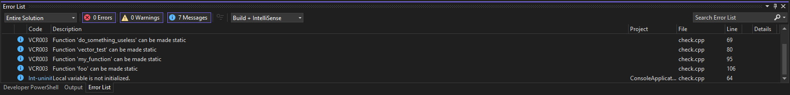

I used Visual Studio to run built-in static analysis and reviewed all warnings and messages in the Error List. Then, I ran Cppcheck on the same source file with all checks enabled, including inconclusive and C++17 standard. Visual Studio primarily flagged stylistic issues, while Cppcheck identified deeper logic errors like infinite recursion, unsafe memory use, and iterator invalidation. I compared both sets of results to identify risks and determine which tool detected each issue.